Creating C Projects in XCode 3.2.1

1. Open up XCode:

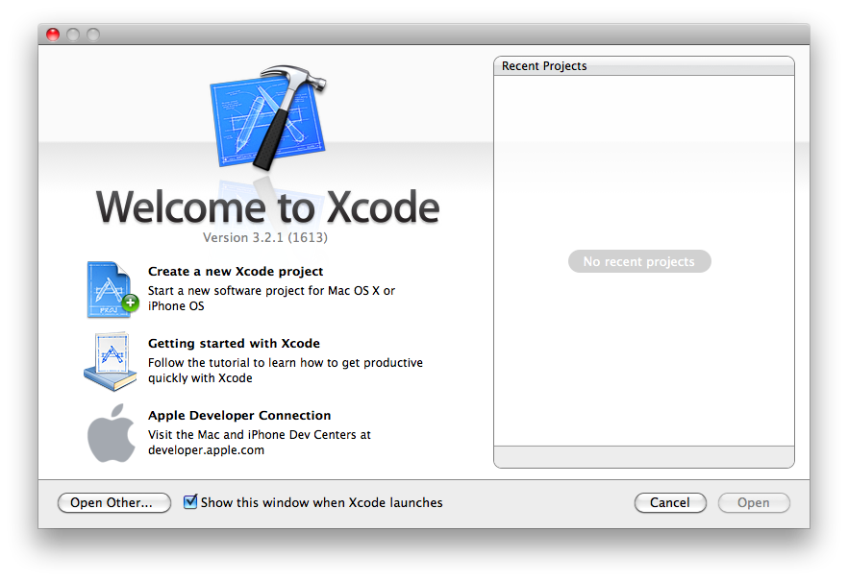

1. Select “Create a new Xcode project”, and you will be presented with:

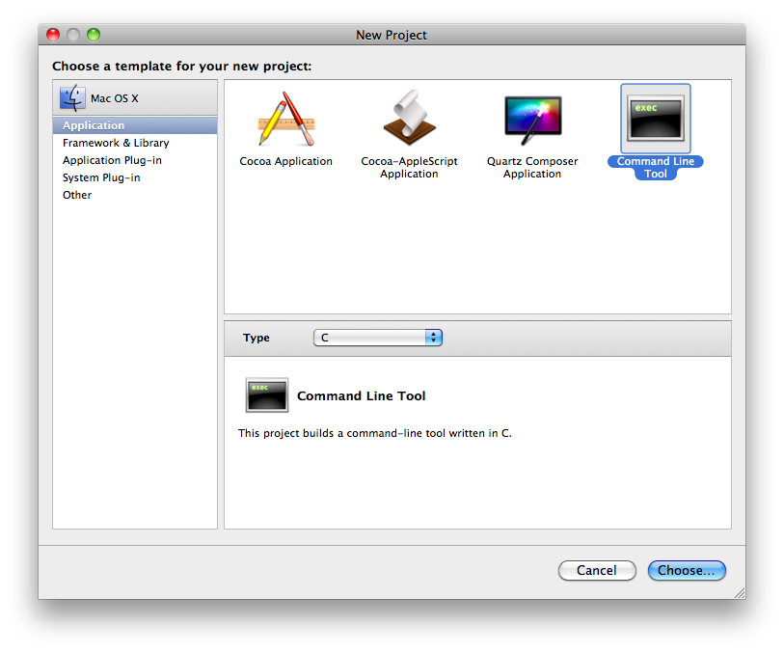

Choose “Command Line Tool” and “C” for the application type.

1. Choose a name for the new project:

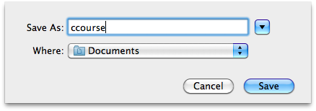

1. Now a few settings need to be changed; select the “Project” menu then “Edit Project Settings”. Choose “All Configurations” for the configuration, then scroll down to “C Language Dialect” (Under “GCC 4.2 – Language”), and select “ANSI C” for the dialect:

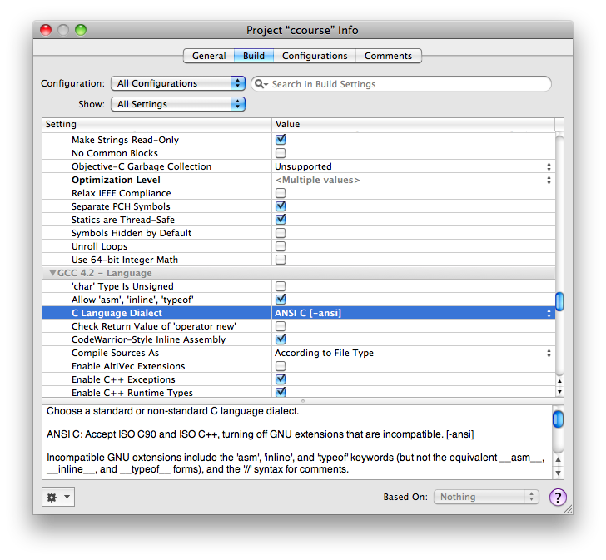

1. Now scroll down to and select “Pedantic Warnings” (underneath GCC 4.2 – Warnings):

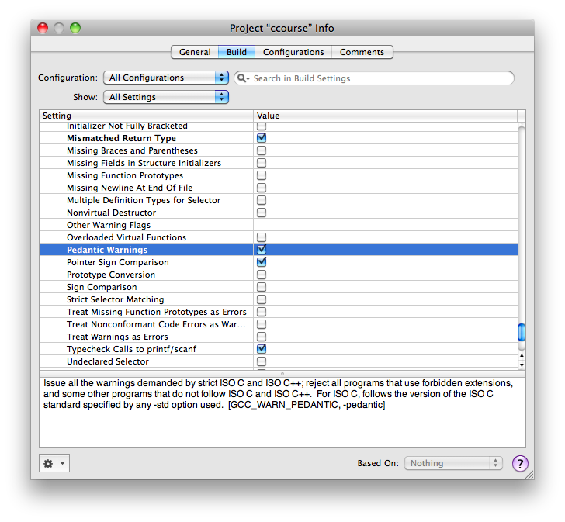

1. Now if you have invalid C code (such as declarations in the middle of code), the compiler will pick them up for you:

